DP1 2020-2021

Requirements Document and System Analysis

Standby Project

https://github.com/gii-is-DP1/dp1-2020-gi-04

# Group members <alphabetic order by surname>:

* Bogdan, George Laurentiu
* Diz Gil, Guillermo
* Muñoz Pérez, Carmen María
* Rodríguez Pérez, Francisco

Professor: José María García

# GROUP GI-04

## Version 3

Friday 30th October 2020

## Changelog

|  |  |  |  |
| --- | --- | --- | --- |
| Date | Version | Description | Sprint |
| 30/10/2020 | V1 | Document creation | 1 |
| 08/11/2020 | V2 | First sprint completed | 1 |
| 29/11/2020 | V3 | Second sprint completed | 2 |
|  |  |  |  |
|  |  |  |  |

# General project description

The short films are the first productions that are usually made by those who want to dedicate themselves to the world of cinema, but at the same time they are ignored in the cultural field within the film industry. The best-known short films are those that win very important awards or are created by very important companies such as Disney. But what about that majority that does not win awards? They always fall into oblivion. Despite all this, almost all the great filmmakers of our time have started making short films and these have been vital in their rise to fame. Thus, the Standby project was born out of the need of both amateur and professional filmmakers who want to make themselves known and make their way in the world of cinema through short films, as well as the need to promote and disseminate the importance of short films within the industry.

For all these reasons, this project aims to provide an application that brings together short films from around the world, as well as serving as a stimulus for those who want to join the film industry. Standby will be an application that will allow filmmakers to share their short films. Thus, users will be able to watch, comment and evaluate these short films. In addition, companies will be able to filter them and access additional information that will allow them to contact the filmmakers for possible hiring.

# User types / roles

***Unregistered user:*** *users that visits our page without registering.*

***User:*** *users interested in watching, reviewing and commenting them.*

***Filmmaker:*** *content creators, they can upload short films and tag people in their projects or be tagged with a specific role.*

***Company:*** *companies looking for filmmakers to hire.*

# User stories

**H1 - Register account as a filmmaker**

**As an** unregistered filmmaker, **I want the system** to allow me to create a user account, **so that** I can enjoy all the functionality of a registered filmmaker.

**H1+E1 –** **Filmmaker registration**

**Since** I am not authenticated in the system **when** I press the button “Register as a filmmaker” to go to register **once** I enter the obligatory fields which are: name “GuilleX7”, full name “Guillermo Diz Gil”, email “guillermox7@gmail.com”, password “NbcxhPjBcjTxbYdCxbPdnExb”, we leave optional fields blank: country “”, city “”, phone “” **after** pressing the button “Register” to finish this registration **then** I will have created my user and can have all the privileges that this entails.

**H1+E2 –** **Filmmaker registration**

**Since** I am not authenticated in the system **when** I press the button “Register as a filmmaker” to go to register **once** I enter the obligatory fields which are: name “GuilleX7”, full name “Guillermo Diz Gil”, email “guillermox7@gmail.com”, password “NbcxhPjBcjTxbYdCxbPdnExb”, and optional fields: country “Morocco”, city “Rabat”, phone “+34 629428435” **after** pressing the button “Register” to finish this registration **then** I will have created my user and can have all the privileges that this entails.

**H1-E1 – Filmmaker registration only with the name field**

**Since** I am not authenticated in the system **when** I press the button “Register as a filmmaker” to go to register **once** I enter only our name “Anageo183” , fullname “”, email “”, password “”, country “”, city “”, phone “” **then** the application shows us the edition form again and tells us “Error: The mandatory fields are not completed”.

**H2 - Register account as a company**

**As a** company, **I want the system** to allow me to create a company account, **so that** I can enjoy all the functionality of a registered company.

**H2+E1 –** **Company registration**

**Since** we are not authenticated in the system **when** we press the button “Register as a company” to go to register **once** we enter the mandatory fields which are name “hollymollystudios”, email “hollymolly@studios.com”, password “ShidnVoHioZdhEjI”, tax ID number “0760345958”, the name of the company “Holly Molly Studios”, business phone “+40 0731264578” and office address “Bulevardul Tomis 314, Constanța 900860, Romania” **after** pressing the button to finish this registration **then** I will have created my user and can have all the privileges that this entails.

**H2-E1 – Company registration only with the email field**

**Since** we are not authenticated in the system **when** we press the button “Register as a company” to go to register **once** we enter only our email “hollymolly@studios.com”, name “”, password “”, business phone “”, name of the company “”, tax ID number “”and office address “” **after** pressing the button “Register” to finish this registration **then** the application shows us the edition form again and tells us “Error: all the fields are mandatory and cannot be empty”.

**H3 – User login**

**As a** user, **I want the system** to allow me to log in the system, **so that** I can make use of my account.

**H3+E1 –** **User/Company login**

**Since** I am unauthenticated in the system **when** I press the button “Login” to go to the application login **once** I enter our username “GuilleX7” and password “NbcxhPjBcjTxbYdCxbPdnExb” **after** pressing the button “Login” to finish the authentication **then** I am redirected to the feed page and our account information shows up in the header.

**H3-E1 – User/Company login only with the username field**

**Since** we are unauthenticated in the system **when** we press the button “Login” to go to the application login **once** we enter our username “hollymollystudios”, password “” **after** pressing the button “Login” to finish the authentication **then** the application tells us “Error: the user or the password are incorrect”.

**H3-E2 – User/Company login only with the username field**

**Since** I am unauthenticated in the system **when** I press the button “Login” to go to the application login **once** I enter our username “GuilleX7” and an incorrect password “RocketLeague” by mistake **after** pressing the button “Login” to finish the authentication **then** the application tells me “Error: the user or the password are incorrect”.

**H4 – Comments and ratings deletion**

**As a** user, **I want the system** to allow me to delete my comments and the ratings I have done **so that** I can keep control of what I do.

**H4+E1 –** **Comment deletion**

**Since** I am authenticated in the system as the user “GuilleX7” **when** I go a short film where I have written a comment **once** press the button “Delete” **after** pressing it **then** the comment and all the data related with it must be deleted from the system.

**H4+E2 –** **Rating deletion**

**Since** I am authenticated in the system as the user “GuilleX7” **when** I go a short film which I have rated **once** press the button “Remove my rating” **after** pressing it **then** the rating must be erased from the system, and its influence from any kind of rating mean should disappear.

**H5 - Upload short films**

**As a** filmmaker, **I want the system** to allow me to upload short films, **so that** anyone can see them.

**H5+E1 –** **Upload short films**

**Since** I am authenticated in the system as the user “GuilleX7” **when** I press the button “Upload a new short film”, I am redirected to the upload film page, so I can input the film name “The good mother”, film description: “This is my first short film ever! Hope you like it”, I choose the file “C:\Users\GuilleX7\Desktop\My_Short_Film.mp4” containing my film and press the “Upload” button **after** pressing the button “Confirm upload” to finish the operation **then** the short film will have been successfully uploaded to my account and I are redirected to the short film editing page.

**H5-E1 – Upload short films with invalid extension**

**Since** I am authenticated in the system as the user “GuilleX7” **when** I press the button “Upload a new short film”, I am redirected to the upload film page, so I can input the film name “The good mother”, film description: “This is my first short film ever! Hope you like it”, I choose the file “C:\Users\GuilleX7\Desktop\My_Favourite_Music.mp3” containing music and press the “Upload” button **after** pressing the button “Confirm upload” to finish the operation **then** the system will throw me an error: “The uploaded file is not a supported video file”.

**H6 - View short films**

**As a** user or unregistered user, **I want the system** to allow me to view short films and all the tags, comments and the rating the short film is associated to, **so that** I can enjoy the content and have an idea of what I am watching.

**H6+E1 –** **Viewing a short film without being registered**

**Since** I am not authenticated in the system **when** I look up for a user profile “GuilleX7” which has 3 short films uploaded “The good mother”, “Rocket Liga” and “Escaping Romania” **once** I select the short film “The good mother” **after** pressing the play button **then** it redirects me to the film view page so I can play the short film, see all the comments, the global rating and the tags associated to the film in the description.

**H7 – Manage filmmakers involved in a short film**

**As a** filmmaker, **I want the system** to allow me to manage the users involved in a short film and their respective roles **to** give them credit.

**H7+E1 –** **Adding roles to a short film**

**Since** I am authenticated in the system as “CarmenM” **when** I select the short film “The Impossible” I want to edit **once** I set roles as: “Actor: ‘CarmenM’, Soundtrack composer: ‘Beethoven’”, **after** pressing button “Confirm” to finish the operation **then** the short film “The Impossible” will have been successfully updated.

**H7+E2 –** **Adding roles to a short film (2)**

**Since** I am authenticated in the system as “CarmenM” **when** I select the short film “The Impossible” I want to edit **once** I set roles as: “Producer: ‘Mustang’, Makeup artist: ‘Ter’” that I want to add **after** pressing the button “Confirm” to finish the operation **then** the short film “The Impossible” will have been successfully updated.

**H7+E3 –** **Deleting roles to an uploaded short film**

**Since** I am authenticated in the system as “CarmenM” **when** I select the short film “The Impossible” I want to edit **once** I click on the remove button of the following roles: “Producer: ‘Mustang’, Makeup artist: ‘Ter’” that I want to delete **after** pressing the button “Confirm” to finish the operation **then** the short film “The Impossible” will have been successfully updated.

**H7-E1 –** **Deleting all your roles of an uploaded short film**

**Since** I am authenticated in the system as “CarmenM” **when** I select the short film “The impossible” I want to edit **once** I indicate the roles “Actor: ‘CarmenM’” that I want to delete **after** pressing the button “Confirm” to finish the operation **then** the application will show me “Error: you must have a role in this film” and the short film´s roles will not be edited.

**H8 - Comment and evaluate short films**

**As a** user, **I want the system** to allow me to comment and evaluate the short films, **so that** I can share my opinion the short film.

**H8+E1 – Add a comment being registered**

**Since** I am authenticated in the system as “CarmenM” **when** I choose a user profile “GuilleX7” which has 3 short films uploaded “The good mother”, “Rocket Liga” and “Escaping Romania” **once** I select the short film “Scaping Romania” **after** trying to add “A truly masterpiece for a blindman” as a new comment **then** the comment will appear with the rest of the comments of the short film.

**H8+E2 – Add a rate being registered**

**Since** I am authenticated in the system as “CarmenM” **when** I choose a user profile “GuilleX7” which has 3 short films uploaded “The good mother”, “Rocket Liga” and “Escaping Romania” **once** I select the short film ”Rocket Liga” **after** trying to add “7.3” as the shortfilms´s rate **then** the score will be added to the rest of the short film's rating.

**H8-E1 – Add a comment without being registered**

**Since** I am not authenticated in the system **when** I choose a user profile “GuilleX7” which has 3 short films uploaded “The good mother”, “Rocket Liga” and “Escaping Romania” **once** I select the short film “Escaping Romania” **after** trying to add “An inspiring and breathtaking film to be seen with a sleeping mask” as a new comment **then** the application will not allow me to add that comment and the application will show me “Error: you must be registered to do this action” and the button “register”.

**H8-E2 – Add a rate without being registered**

**Since** I am not authenticated in the system **when** I choose a user profile “GuilleX7” which has 3 short films uploaded “The good Mother”, “Rocket Liga” and “Scaping Romania” **once** I select the short film “Scaping Romania” **after** trying to add “7.7” as a rate **then** the application will not allow me to add that score and the application will show me “Error: you must be registered to do this action” and the button “register”.

**H9 – Tag short films**

**As a** filmmaker, **I want the system** to allow me to assign multiple tags to a short film, **so that** I can categorize its content.

**H9+E1 – Tag short films with different and unique tags**

**Since** I am a registered user “GuilleX7” and I am tagging one of my uploaded short films “Scaping Romania” **when** I am writing that tags related to the short film **once** I have finished to write all the tags: ’ “#drama”, “#action”, “#historic” , **then** I will have post our tags on my short film so all the other users can find my short film filtering by those tags.

**H9-E1 – Tag short films with duplicate tags**

**Since** I am a registered user “GuilleX7” and I am tagging one of my uploaded short films “Scaping Romania” **when** I am writing that tags related to the short film **once** I have finished to write all the tags: ’ “#drama”, “#action”, “#historic” , “#drama”, **then** the application will show me “Error: duplicate tags are not allowed” and the tags won’t be added.

**H10 - Request personal data of a filmmaker with private information**

**As a** company, **I would like the system** to allow me to request the personal data of a filmmaker with private information, **so that** I can contact him or her for possible employment.

**H10+E1 –** **Request personal data as a company**

**Since** we are a registered company “Netflix” , **when** I send a privacy request to a filmmaker “Fco-film” **once** I press the button “Send pivacy request” in the filmmakers’ profile, **after** the request is sent **then** the filmmaker can accept or deny my request, if it is accepted the information should be now available to me.

**H10-E1 – Request personal data as a user**

**Since** I am a registered user named “CarmenM” **when** I send a request to a filmmaker **once** I press the button “Send privacy request” in the filmmakers’ profile **after** I notice the button is disabled **then** the application will show me a message “ you must be a company to send this request”.

**H10-E2 – Request personal data of user as a company for a second time**

**Since** we are a company named “talent-spotter” looking for hiring the filmmaker “CarmenM” **when** we have looked up to her profile **once** we select and enter her profile **after** we notice the button “Send privacy request” is disabled **then** we clicked on that button and the application will show us: “You cannot request this user private data again”.

**H11 - Search short films and filmmakers by filters**

**As a** user or unregistered user, **I want** to be able to look for short films by a certain title, that contain a certain tag or tags, by trending (best reviewed or most commented), by upload date, by duration, or filmmakers by his name, **so that I am** able to look for the content I am interested in.

**H11+E1 – Filtering short films by films title**

**Since** I am a user named “GuilleX7” **when** I want to see a short film named “The Impossible” **once** I put the title “The Impossible” in search box **after** I made the search **then** the application will show me the main films with that name.

**H11+E2 – Filtering short films by films tags**

**Since** I am a user named “GuilleX7” **when** I want to see a short film related to the drama **once** I put the tag “#drama” in search box **after** I made the search **then** the application will show me the main films with that tag attached.

**H11+E3 – Filtering short films by rating**

**Since** I am a user named “GuilleX7” **when** I want to see the best short film of all time **once** I select “best rated” as option in the search box **after** I made the search **then** the application will show me the best rated films in descending order.

**H11+E4 – Filtering users by name**

**Since** I am a user named “GuilleX7” **when** I want to look for a filmmaker named “CarmenM” in the application **once** I write “CarmenM” in the search box **after** I made the search **then** the application will show me CarmenM profile as one of the search results.

**H11-E1 – Filtering user that does not exist in the system**

**Since** I am an unregistered **when** I want to see the profile of a non-existent user named “CarmenK” **once** I put her name in the search box **then** the application will show me no results.

**H11-E2 – Filtering short films by films tags that does not exist**

**Since** I am a user named “GuilleX7” **when** I want to see a short film related to the drama **once** I put the tag “#drama” in the search box **after** I made the search **then** the application will show me: “There are not films attached to this tag”

**H11-E3 – Filtering short films by films title that does not exist**

**Since** I am a user named “GuilleX7” **when** I want to see a short film named “The Impossible” **once** I put the title “The Impossible” in the search box **after** I made the search **then** the application will show me: “There are not films attached to that title”

**H12 – View filmmaker’s profile**

**As a** user or unregistered user, **I want the system** to display the profile of a given filmmaker, showing his username, profile picture and all the short films that the filmmaker has uploaded or has appeared in **in order to** view information about a filmmaker.

**H12+E1 –** **List the films where I am tagged as a filmmaker**

**Since** I am a filmmaker named “Fco-film”, **when** I go to my profile **once** I press the profile button, **after** I enter the short films section **then** the system shall list every short film where I have participated in and my role in there.

**H12+E2 –** **Enter the profile of a certain filmmaker**

**Since** I am an unregistered user, **when** I want to look for the profile of “CarmenM” **once** I write her account name in the search bar, **after** clicked on his profile **then** the application will take me to her profile.

**H12-E1 –** **Enter my profile as an unregistered user**

**Since** I am an unregistered user, **when** I want to enter my own profile **once** I press the profile button **then** the application will redirect me to the login page.

**H13 – Edit short film information**

**As a** filmmaker, **I want the system** to allow me to edit all the information related to a short film **to** keep the short film information up to date.

**H13+E1 – Edit short film name and description**

**Since** I am a filmmaker, **when** I want to edit the information of the short film named “Armageddon” **once** we press the edit button, I write the title as “Armageddon 2” and the description “This is a short film about asteroids and space”, **after** I click the “Submit changes” button **then** the short film must have changed its name and description.

**H13-E1 – Edit short film with name missing**

**Since** I am a filmmaker, **when** I want to edit the information of the short film named “Armageddon” **once** we press the edit button, I leave the title empty and the description “This is a short film about asteroids and space”, **after** I click the “Submit changes” button **then** the system will show me an error saying that “The title of the short film cannot be empty”.

**H13-E2 – Edit short film with description missing**

**Since** I am a filmmaker, **when** I want to edit the information of the short film named “Armageddon” **once** we press the edit button, I leave the title empty and the description “This is a short film about asteroids and space”, **after** I click the “Submit changes” button **then** the system will show me an error saying that “The description of the short film cannot be empty”.

**H14 – Save short film as favourite**

**As a** user, **I want** to be able to save my favourites short films, **so that** I cansee I can access them easily.

**H14+E1 –** **Register my favourite short film as a registered user**

**Since** I am a registered user named “Fco-film” **when** I want to save a short film named “The Impossible” **once** I choose the short film I want to save **after** pressing the button “Save as favourite” **then** the short film will be saved in my favourites tab.

**H14-E1 – Register my favourite short film as an unregistered user**

**Since** I am an unregistered user **when** I want to save a short film named “Escaping Romania” **once** I choose the short film I want to save **after** pressing the save button **then** the application will give us: “Error: you need to be logged in to save short films”

**H15 – List all favourite short films**

**As a** user, **I want** to be able to save my favourites short films, **so that** I cansee I can access them easily.

**H15+E1 –** **Accessing my favourite short film list**

**Since** I am a registered user named “CarmenM” **when** I want to access my favourite short films list **once** I enter on my profile **after** pressing the button “saved” **then** I will have access to all my favourite short films.

**H15+E2 –** **Accessing my favourite short film list when it is empty**

**Since** I am a registered user named “Fco-films” **when** I want to access my favourite short films list **once** I enter on my profile **after** pressing the button “saved” **then** the application will show me: “You have no favourite short films”.

**H16 - Subscription to filmmaker**

**As a** user, **I want** to be able to subscribe to a filmmaker, **so that** I cansee his/her newest activity.

**H16+E1 –** **Subscribe to a filmmaker as a registered user**

**Since** I am a registered user named “GuilleX7” **when** I want to follow the activity of a filmmaker named “CarmenM” **once** I choose the filmmaker profile I want to follow **after** pressing the button “follow” in ”CarmenM” profile **then** I will be following her and the new activities will appear in our feed.

**H16-E1 – Subscribe to a filmmaker as an unregistered user**

**Since** I am an unregistered user **when** I want to follow the activity of a filmmaker **once** I choose the filmmaker “Fco-films” I want to follow **after** pressing the follow button in the filmmakers’ profile **then** the application will show me: ”Error: you must be registered to do this action”.

**H16-E2 – Subscribe to yourself**

**Since** I am a registered user named “GuilleX7” **when** I want to myself **once** I enter on my own profile **after** searching the “follow” button **then** I will notice that there is not “follow” button on my profile.

**H17 – Receive notifications**

**As a** user, **I want** to be able to receive notifications for subscription to our profiles, ratings or comments posted in our short films or for received privacy requests, and if we are a company, for accepted private requests, **so that** I canbe up to date with the latest activity.

**H17+E1 –** **A user post a comment on my uploaded short film**

**Since** I am a registered user named “Fco-film” **when** the user “CarmenM” comments on my short film “A Good Day to Die” **then** a new notification will appear in my notification bell “CarmenC has posted a comment on your post”.

**H17+E2 –** **A user rates my uploaded short film**

**Since** I am a registered user named “Fco-film” **when** the user “CarmenM” rates on my short film “A Good Day to Die” **then** a new notification will appear in my notification bell.

**H17+E3 – Receiving privacy request notification as a user**

**Since** I am a registered user named “Fco-films”, **when** company account sends me a privacy request **once** the privacy request has been sent **then** a new notification will appear in my notification bell.

**H17+E4 – Receiving the approval privacy request notification**

**Since** we are a company named “talent-spotter” looking for hiring the filmmaker “CarmenM” **when** we have already sent her the privacy request **once** we wait for her to response **after** she actually responds the privacy request **then** the company at issue will be notified by the application about the CarmenM´s approval.

**H17+E5 – Receiving the refusal privacy request notification**

**Since** we are a company named “talent-spotter” looking for hiring the filmmaker “CarmenM” **when** we have already sent her the privacy request **once** we wait for her to response **after** she actually responds the privacy request **then** the company at issue will be notified by the application about the CarmenM´s refusal.

**H18 - Manage notifications**

**As a** user, **I want** to be able to choose which types of activities I want to be notified of, **so that** I candecide which type of activity I care about.

**H18+E1 –** **Select to be notified only by comments**

**Since** I am a registered user named “CarmenM” **when** I want to filter the notifications that I want to receive **once** I choose only ”Comments in my short films” **after** pressing the button “Confirm changes” **then** the application will only notify me about comments that other users make in my short films.

**H18+E2 –** **Select to be notified only by rate**

**Since** I am a registered user named “CarmenM” **when** I want to filter the notifications that I want to receive **once** I choose only ”Ratings given to my short films” **after** pressing the button “Confirm changes” **then** the application will only notify me about comments that other users make in my short films.

**H18+E3 –** **Select to be notified only by subscriptions to my profile**

**Since** I am a registered user named “CarmenM” **when** I want to filter the notifications that I want to receive **once** I choose only ”Subscriptions to my profile” **after** pressing the button “Confirm changes” **then** the application will only notify me about comments that other users make in my short films.

**H18+E4 –** **Select to be notified only by privacy request status changes**

**Since** we are a registered company named “Holly Molly Studios” **when** I want to filter the notifications that I want to receive **once** I choose only ”Privacy request status changes” **after** pressing the button “Confirm changes” **then** the application will only notify me about comments that other users make in my short films.

**H19 – Edit account information**

**As a** user, **I want** to be able to modify the data of my account, **so that** I can keep the information up to date.

**H19+E1 –** **Editing my profile´s photo and city**

**Since** I am a registered user named “Fco-films” **when** I want to update my city “Huelva” to “Seville” and to upload a new profile photo **once** I enter my profile and click on the button “Edit my profile” **after** going to my profile form and editing those things  **then** the application will update my profile with that new data.

**H19+E2 –** **Changing my account name with another one which is not taken**

**Since** I am a registered user named “Fco-films” **when** I want to update my account name to “Fco-Trash” **once** I enter my profile and click on the button “Edit my profile” **after** going to my profile form and editing my account **then** the application will check if that name is available and will update my account name.

**H19-E1 –** **Changing my account name with another one which is taken**

**Since** I am a registered user named “Fco-films” **when** I want to update my account name to “Fco-Trash” **once** I enter my profile and click on the button “Edit my profile” **after** going to my profile form and editing my account **then** the application will check if that name is available and will not update my profile name showing a message: “That account name is already taken”.

**H19-E2 –** **Changing my email account**

**Since** I am a registered user named “Fco-films” **when** I want to update my account email to ”example5555@gmail.com” **once** I enter my profile and click on the button “Edit my profile” **after** looking for the email-field **then** I will notice that the email field is disable and cannot be edited.

**H20 – Show feed at land page**

**As a** user or unregistered user, **I want** to see either my feed If I am registered or random short films if I am not registered, **so that** I can be up to date with the latest activity.

**H20+E1 –** **Accessing the feed as a registered user**

**Since** I am a registered user named “Fco-films” **when** I want to access to my feed **once** I clicked on the “home” button  **then** the application will lead me to my feed where I can see the last uploads of the filmmakers I am following.

**H20+E2 –** **Accessing the feed as an unregistered user**

**Since** I am an unregistered user **when** I want to access to random uploads **once** I clicked on the “home” button  **then** the application will lead me to my feed where I can see the last uploads of random filmmakers.

# User stories mockups

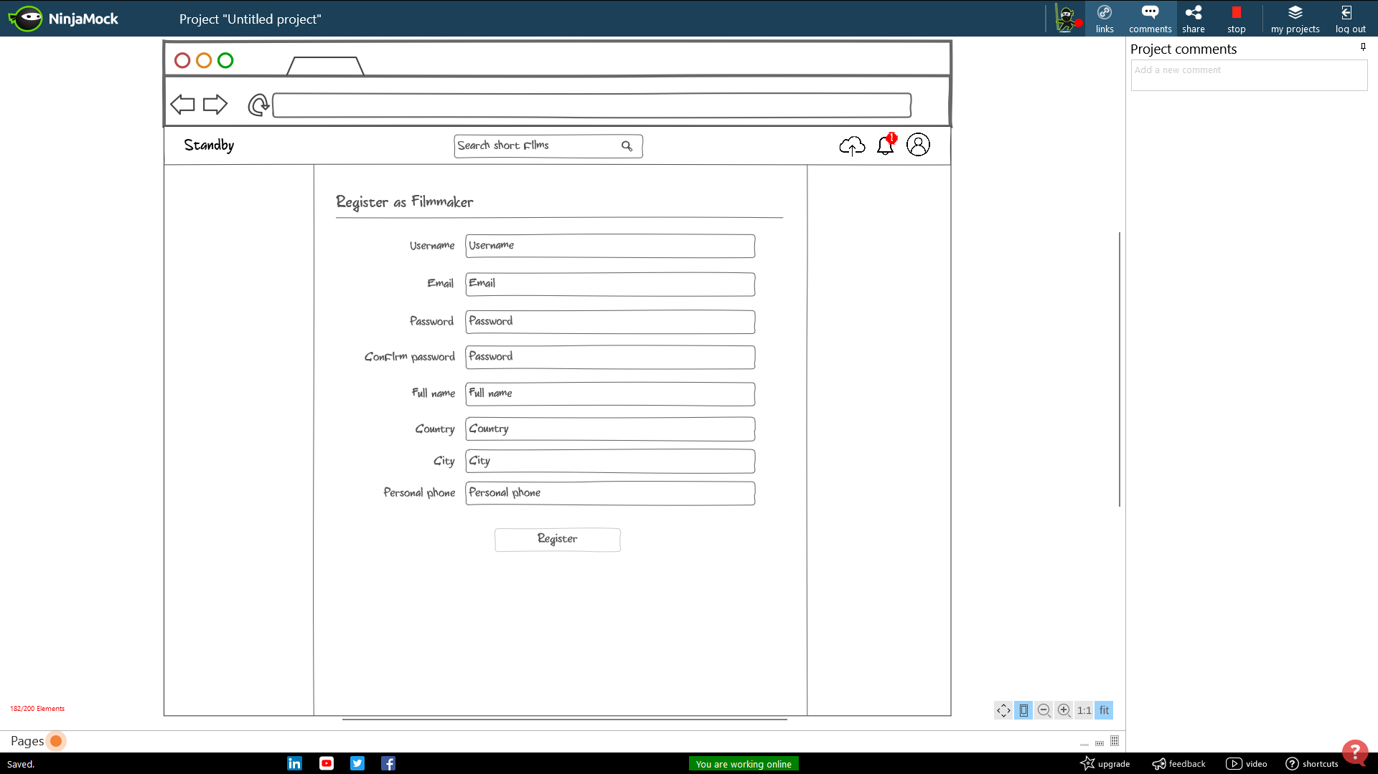Register as filmmaker – associated with user story H1

### 

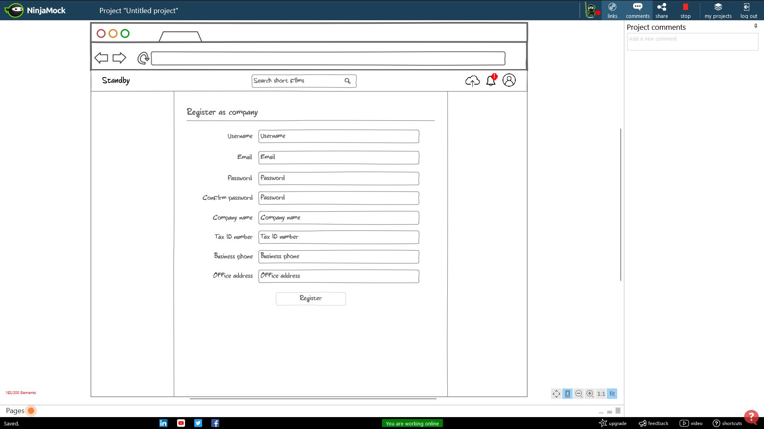Register as company – associated with user story H2

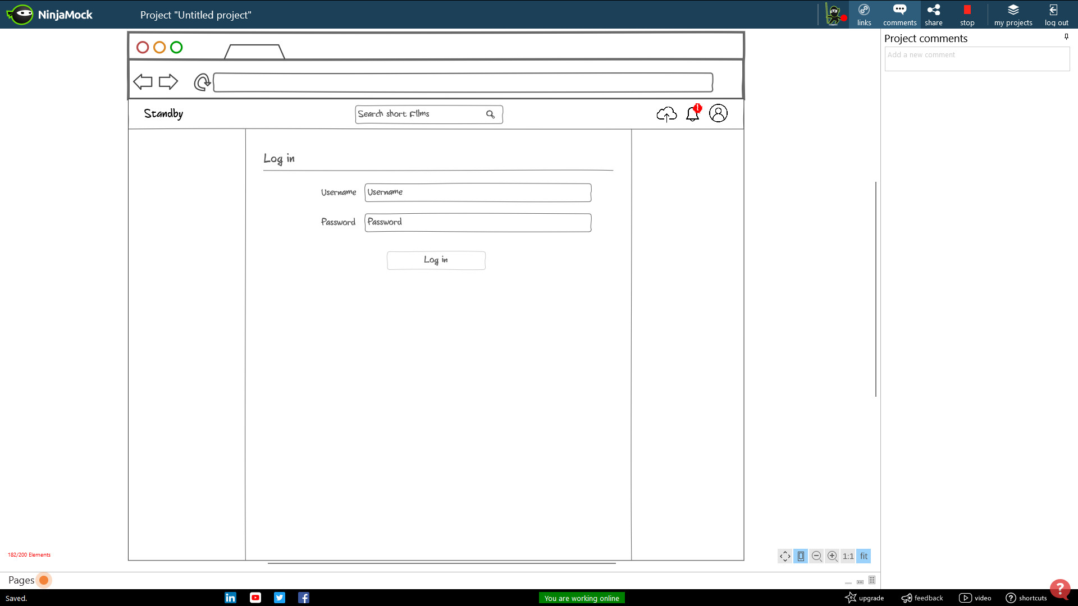Log in – Associated with user story H3

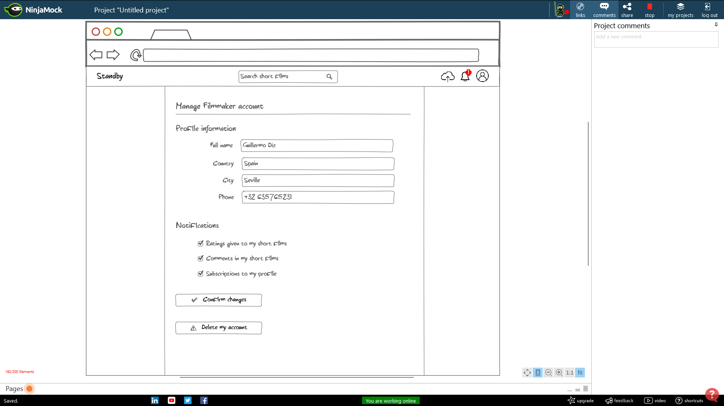Manage filmmaker’s account – associated with user stories H4, H18, H19

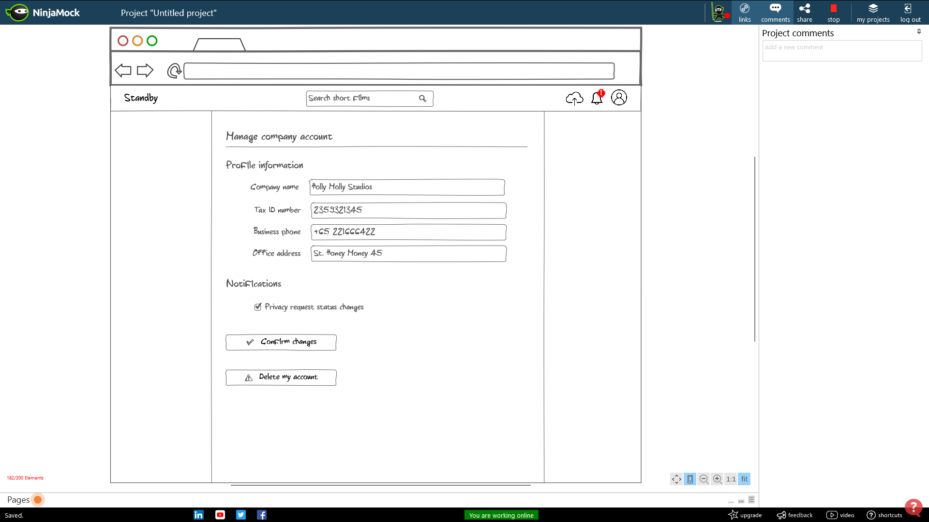Manage company account – associated with user stories H4, H18, H19

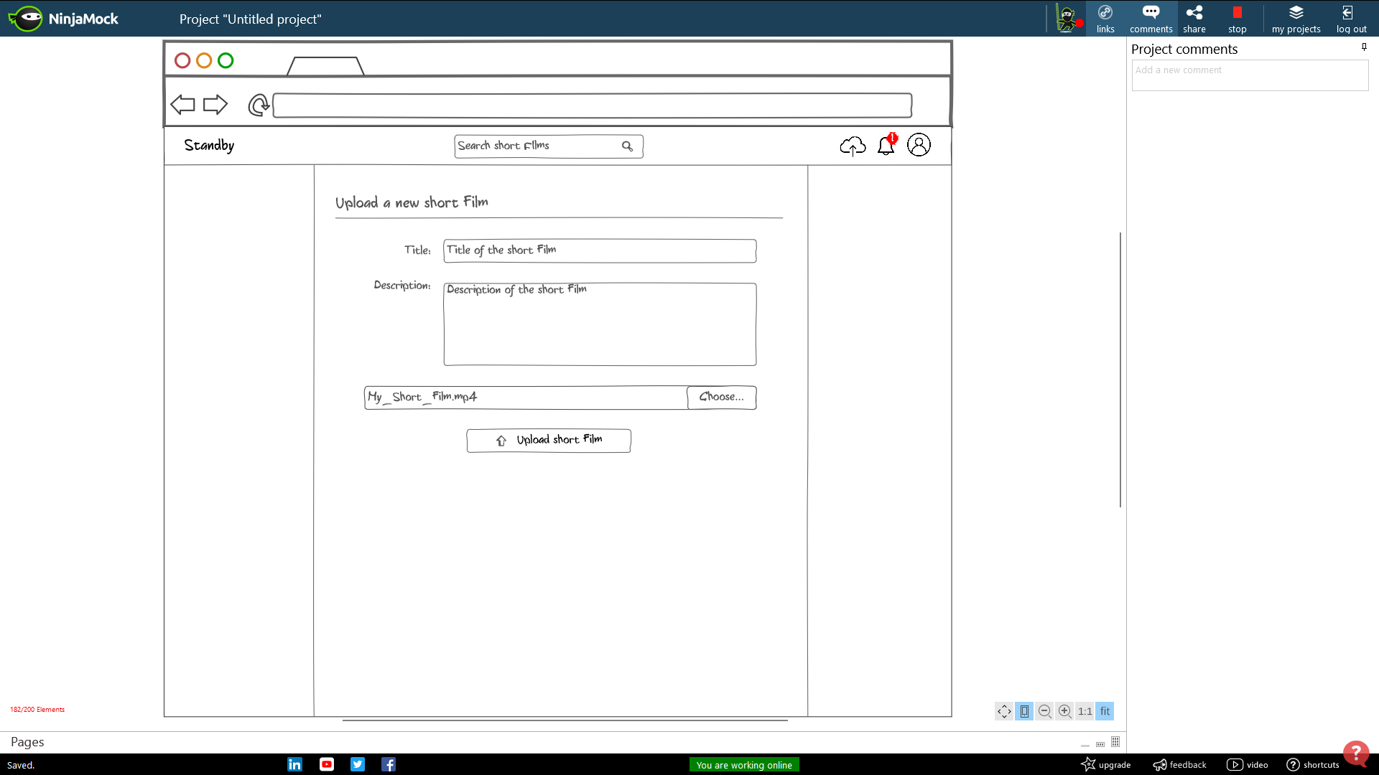Upload short film – Associated with user story H5

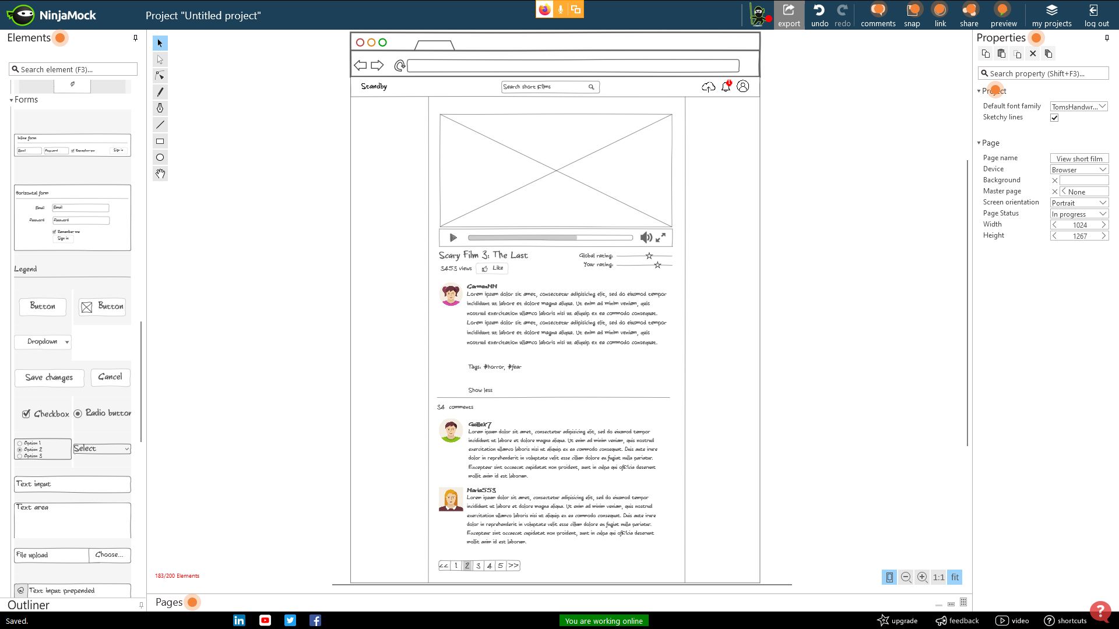View short film – Associated with user stories H6, H8, H14

Edit short film – Associated with user stories H7,H9, H13

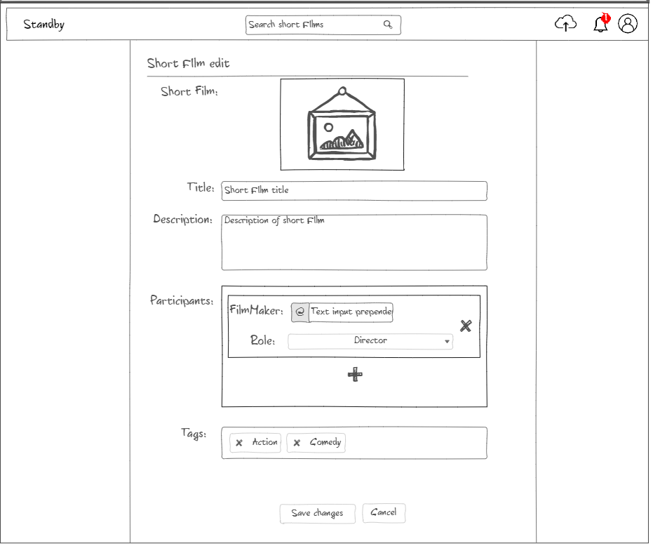

User profile – Associated with user stories H10, H12, H16

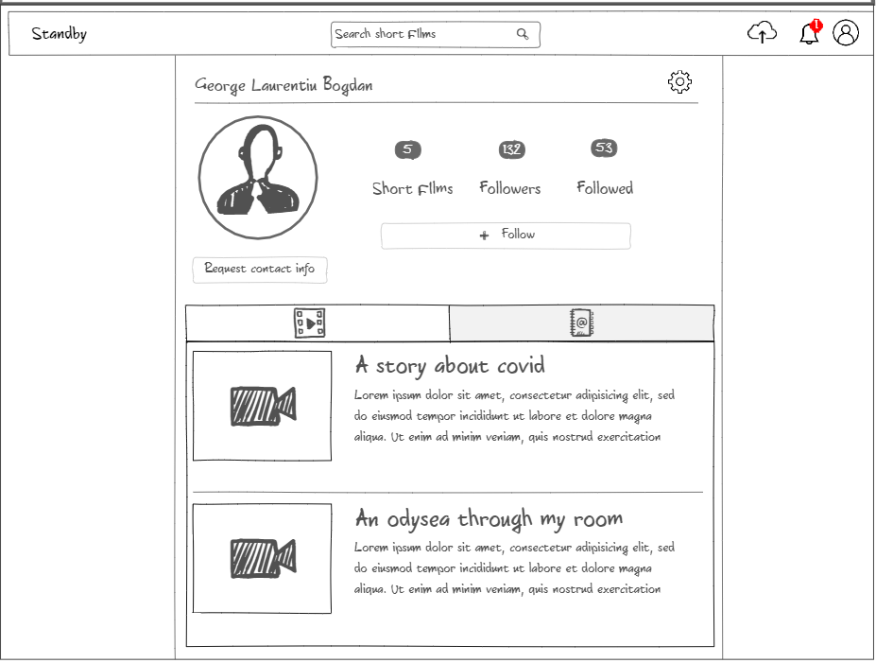

Notifications – Associated with user stories H17

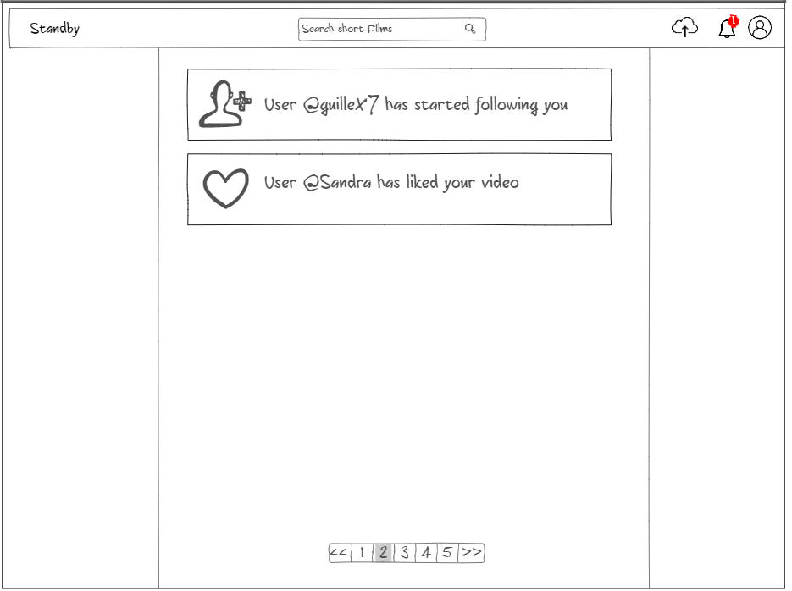

Search short film – Associated with user stories H11

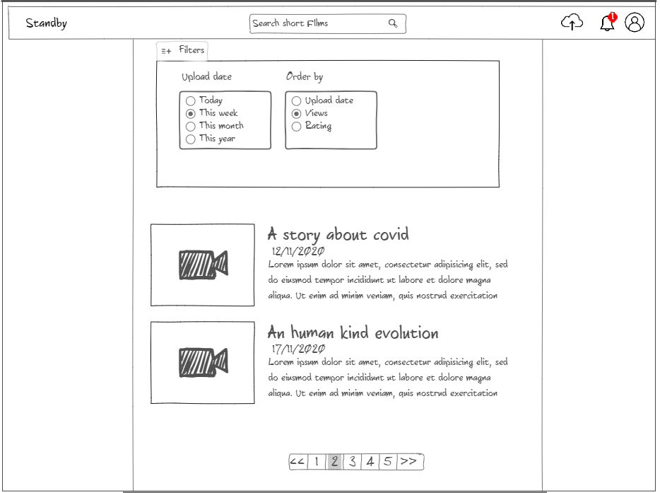

List favourite short films – Associated with user stories H15

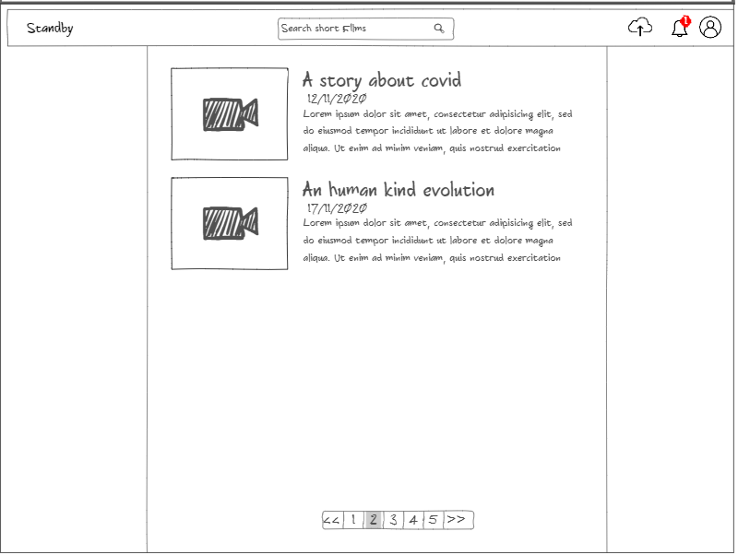

Feed – Associated with user stories H20

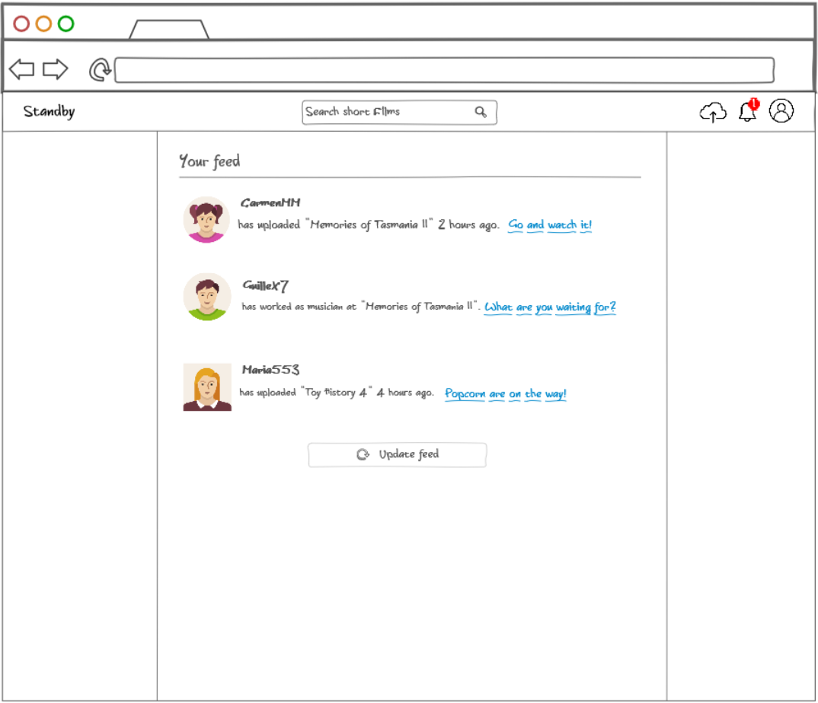

# Data model

# Business rules

**R1 – Subscription to oneself**

A user cannot be subscribed to himself. We allow to subscribe to other filmmakers so people can stay tuned with their latest news, but it makes no sense to subscribe to oneself.

**R2 – Multiple subscriptions**

A user cannot be subscribed more than once to the same filmmaker. A subscription allows you to show the filmmaker activity in your feed, but when you are already subscribed the only option you may have is to unsubscribe.

**R3 – Multiple short film ratings**

A user cannot rate more than once the same short film because a rating is the conclusion you got from the short film. However, you are still allowed to change it whenever you want.

**R4 – Multiple privacy requests**

A company cannot send more than one privacy request to the same filmmaker. If there is an active privacy request, companies only have the option to desist from the request while they wait for the filmmaker to accept or decline it.

**R5 – Privacy requests requirements**

A company can only send privacy requests to filmmakers who have private additional information, because otherwise filmmaker’s personal data will be public for all companies.

**R6 – Same tag**

A short film cannot have the same tag more than once, as a tag is a word or short phrase that gives information about the short film. Duplicating the tag does not give us more information.

**R7 – Relevant notifications**

A user can only be notified for the activity that the user has chosen to be notified of. We will not bother the user with activity he does not care about.

# Planning

|  |  |  |  |
| --- | --- | --- | --- |
| ***Type*** | ***Element*** | ***Assignment*** | ***Sprint*** |
| *Document* | *General description* | *Guillermo Diz*  *Carmen María Muñoz*  *Francisco Rodríguez*  *George Laurentiu Bogdan* | *1* |
| *Document* | *User stories* | *Guillermo Diz*  *Carmen María Muñoz*  *Francisco Rodríguez*  *George Laurentiu Bogdan* | *1* |
| *Data model* | *Class diagram* | *Guillermo Diz*  *Carmen María Muñoz*  *Francisco Rodríguez*  *George Laurentiu Bogdan* | *1* |
| *Data model* | *Business rules* | *Guillermo Diz*  *George Laurentiu Bogdan* | *1* |
| *Document* | *Use cases* | *Carmen María Muñoz*  *Francisco Rodríguez*  *George Laurentiu Bogdan* | *1* |
| *Backend* | *Environment set-up* | *Guillermo Diz* | *1* |
| *Frontend* | *Environment set-up* | *George Laurentiu Bogdan* | *1* |
| *Backend* | *First entity mapping* | *Guillermo Diz George Laurentiu Bogdan* | *1* |
| *Document* | *Reviewing* | *Guillermo Diz George Laurentiu Bogdan Carmen María Muñoz Francisco Rodríguez* | *2* |
| *Document* | *User cases* | *Carmen María Muñoz Francisco Rodríguez* | *2* |
| *Mockup* | *H1 to H20* | *Guillermo Diz George Laurentiu Bogdan* | *2* |
| *Entity* | *User* | *Guillermo Diz*  *Carmen María Muñoz* | *2* |
| *Entity* | *ShortFilm* | *Guillermo Diz*  *Carmen María Muñoz* | *2* |
| *Entity* | *Role* | *Guillermo Diz*  *Carmen María Muñoz* | *2* |
| *Entity* | *Rating* | *Guillermo Diz*  *Carmen María Muñoz* | *2* |
| *Entity* | *PrivacyRequest* | *Guillermo Diz*  *Carmen María Muñoz* | *2* |
| *Entity* | *Notification* | *George Laurentiu Bogdan*  *Francisco Rodríguez* | *2* |

|  |  |  |  |
| --- | --- | --- | --- |
| *Entity* | *Comment* | *George Laurentiu Bogdan*  *Francisco Rodríguez* | *2* |
| *Entity* | *Tag* | *George Laurentiu Bogdan*  *Francisco Rodríguez* | *2* |
| *Entity* | *NotificationConfiguration* | *George Laurentiu Bogdan*  *Francisco Rodríguez* | *2* |
| *Entity* | *Company* | *George Laurentiu Bogdan*  *Francisco Rodríguez* | *2* |
| *Entity* | *Filmmaker* | *George Laurentiu Bogdan*  *Francisco Rodríguez* | *2* |
| *Frontend - View* | *Register user* | *George Laurentiu Bogdan*  *Francisco Rodríguez* | *2* |
| *Frontend - View* | *Register company* | *George Laurentiu Bogdan*  *Francisco Rodríguez* | *2* |
| *Backend – User story* | *H1* | *George Laurentiu Bogdan*  *Francisco Rodríguez* | *2* |
| *Backend – User story* | *H2* | *George Laurentiu Bogdan*  *Francisco Rodríguez* | *2* |
| *Frontend - View* | *Login* | *Guillermo Diz*  *Carmen María Muñoz* | *2* |
| *Backend – User story* | *H3* | *Guillermo Diz*  *Carmen María Muñoz* | *2* |
| *Frontend - View* | *Account management* | *Guillermo Diz*  *Carmen María Muñoz* | *2* |
| *Backend – User story* | *H18* | *Guillermo Diz*  *Carmen María Muñoz* | *2* |
| *Backend – User story* | *H19* | *Guillermo Diz*  *Carmen María Muñoz* | *2* |
| *Frontend - View* | *Upload short film* | *George Laurentiu Bogdan*  *Francisco Rodríguez* | *2* |
| *Backend – User story* | *H5* | *George Laurentiu Bogdan*  *Francisco Rodríguez* | *2* |
| *Frontend - View* | *Edit short film* | *Guillermo Diz*  *Carmen María Muñoz* | *2* |
| *Backend – User story* | *H7* | *Guillermo Diz*  *Carmen María Muñoz* | *2* |
| *Backend – User story* | *H9* | *Guillermo Diz*  *Carmen María Muñoz* | *2* |
| *Backend – User story* | *H13* | *Guillermo Diz*  *Carmen María Muñoz* | *2* |
| *Backend – Test* | *H1* | *Guillermo Diz*  *Carmen María Muñoz* | *2* |
| *Backend – Test* | *H2* | *Guillermo Diz*  *Carmen María Muñoz* | *2* |
| *Backend - Test* | *H3* | *George Laurentiu Bogdan*  *Francisco Rodríguez* | *2* |
| *Backend - Test* | *H18* | *George Laurentiu Bogdan*  *Francisco Rodríguez* | *2* |
| *Backend - Test* | *H19* | *George Laurentiu Bogdan*  *Francisco Rodríguez* | *2* |
| *Backend - Test* | *H5* | *Guillermo Diz*  *Carmen María Muñoz* | *2* |
| *Backend - Test* | *H7* | *George Laurentiu Bogdan*  *Francisco Rodríguez* | *2* |
| *Backend - Test* | *H13* | *George Laurentiu Bogdan*  *Francisco Rodríguez* | *2* |
| *Document* | *Sprint analysis* | *Guillermo Diz*  *Carmen María Muñoz*  *Francisco Rodríguez*  *George Laurentiu Bogdan* | *2* |
| *Frontend - View* | *View short film* | *Guillermo Diz*  *George Laurentiu Bogdan* | *3* |
| *Backend – User Story* | *H4* | *Guillermo Diz*  *George Laurentiu Bogdan* | *3* |
| *Backend – User story* | *H6* | *Guillermo Diz*  *George Laurentiu Bogdan* | *3* |
| *Backend – User story* | *H8* | *Guillermo Diz*  *George Laurentiu Bogdan* | *3* |
| *Backend – User story* | *H14* | *Guillermo Diz*  *George Laurentiu Bogdan* | *3* |
| *Frontend - View* | *User profile* | *Carmen María Muñoz*  *Francisco Rodríguez* | *3* |
| *Backend – User story* | *H10* | *Carmen María Muñoz*  *Francisco Rodríguez* | *3* |
| *Backend – User story* | *H12* | *Carmen María Muñoz*  *Francisco Rodríguez* | *3* |
| *Backend – User story* | *H16* | *Carmen María Muñoz*  *Francisco Rodríguez* | *3* |
| *Frontend - View* | *Notifications* | *Guillermo Diz*  *George Laurentiu Bogdan* | *3* |
| *Backend – User story* | *H17* | *Guillermo Diz*  *George Laurentiu Bogdan* | *3* |
| *Backend - Test* | *H4* | *Carmen María Muñoz*  *Francisco Rodríguez* | *3* |
| *Backend - Test* | *H6* | *Carmen María Muñoz*  *Francisco Rodríguez* | *3* |
| *Backend - Test* | *H8* | *Carmen María Muñoz*  *Francisco Rodríguez* | *3* |
| *Backend - Test* | *H14* | *Carmen María Muñoz*  *Francisco Rodríguez* | *3* |
| *Backend - Test* | *H10* | *Guillermo Diz*  *George Laurentiu Bogdan* | *3* |
| *Backend - Test* | *H12* | *Guillermo Diz*  *George Laurentiu Bogdan* | *3* |
| *Backend - Test* | *H16* | *Guillermo Diz*  *George Laurentiu Bogdan* | *3* |
| *Backend - Test* | *H17* | *Carmen María Muñoz*  *Francisco Rodríguez* | *3* |
| *Document* | *Rationale I* | *Guillermo Diz*  *Carmen María Muñoz*  *Francisco Rodríguez*  *George Laurentiu Bogdan* | *3* |
| *Document* | *Sprint analysis* | *Guillermo Diz*  *Carmen María Muñoz*  *Francisco Rodríguez*  *George Laurentiu Bogdan* | *3* |
| *Frontend - View* | *List favourite short films* | *Carmen María Muñoz*  *George Laurentiu Bogdan* | *4* |
| *Backend – User story* | *H15* | *Carmen María Muñoz*  *George Laurentiu Bogdan* | *4* |
| *Frontend - View* | *Search short film* | *Carmen María Muñoz*  *George Laurentiu Bogdan* | *4* |
| *Backend – User story* | *H11* | *Carmen María Muñoz*  *George Laurentiu Bogdan* | *4* |
| *Frontend - View* | *Feed page* | *Guillermo Diz*  *Francisco Rodríguez* | *4* |
| *Backend – User story* | *H20* | *Guillermo Diz*  *Francisco Rodríguez* | *4* |
| *Backend - Test* | *H15* | *Guillermo Diz*  *Francisco Rodríguez* | *4* |
| *Backend - Test* | *H11* | *Guillermo Diz*  *Francisco Rodríguez* | *4* |
| *Backend - Test* | *H20* | *Carmen María Muñoz*  *George Laurentiu Bogdan* | *4* |
| *Document* | *Rationale II* | *Guillermo Diz*  *Carmen María Muñoz*  *Francisco Rodríguez*  *George Laurentiu Bogdan* | *4* |
| *Document* | *Sprint analysis* | *Guillermo Diz*  *Carmen María Muñoz*  *Francisco Rodríguez*  *George Laurentiu Bogdan* | *4* |

# Metrics

|  |  |
| --- | --- |
| **Métrica** | **Valor** |
| **No. of entities (excluding actors)** | *10* |
| **Relations** | *11* |
| **N-to-N relations** | *6* |
| **Simple constraints** | *43* |
| **Business rules** | *7* |
| **Total user stories** | *20* |
| **User stories involving 2 or more entities** | *13* |
| **User stories involving 3 or more entities** | *6* |
| **Actors** | *4* |